**Programming Fundamentals – Lab 1**

## Problem # 1

## Solution:

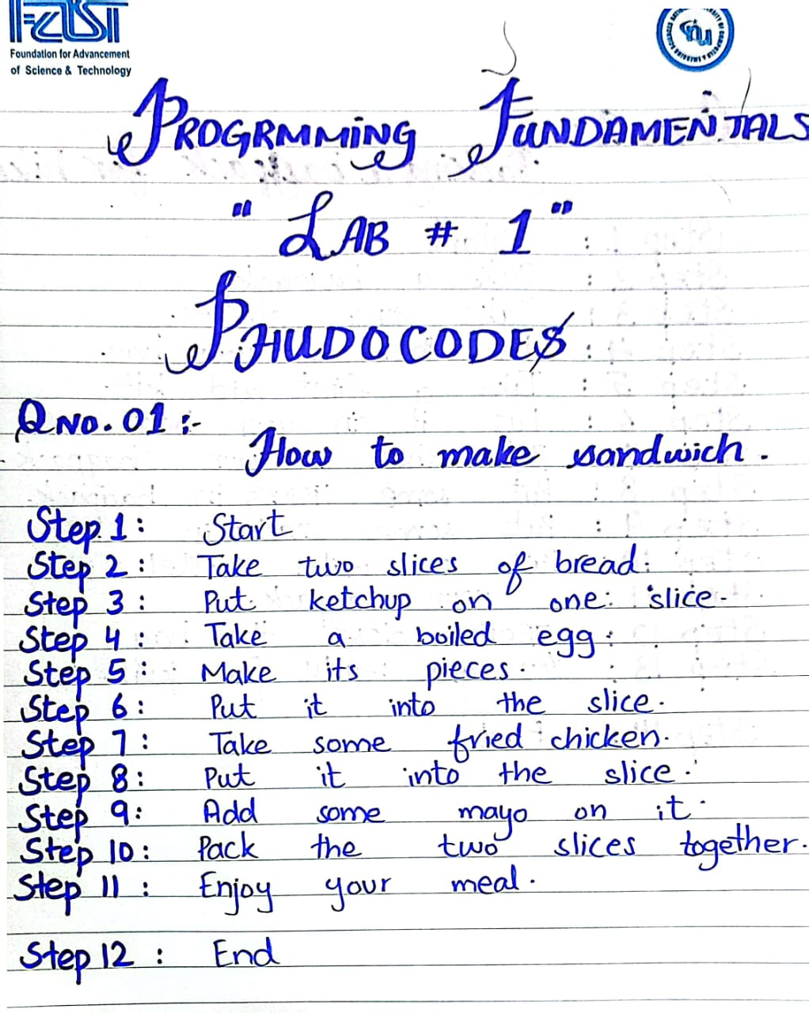

## Problem # 2

## Solution:

# C:\Users\hp\AppData\Local\Temp\Temp1_CamScanner 08-25-2023 10.17[1].zip\CamScanner 08-25-2023 10.17_1.jpg

## Problem # 3

## Solution: C:\Users\hp\AppData\Local\Microsoft\Windows\INetCache\Content.Word\CamScanner 08-25-2023 10.17_2.jpg

## Problem # 4

## Solution:

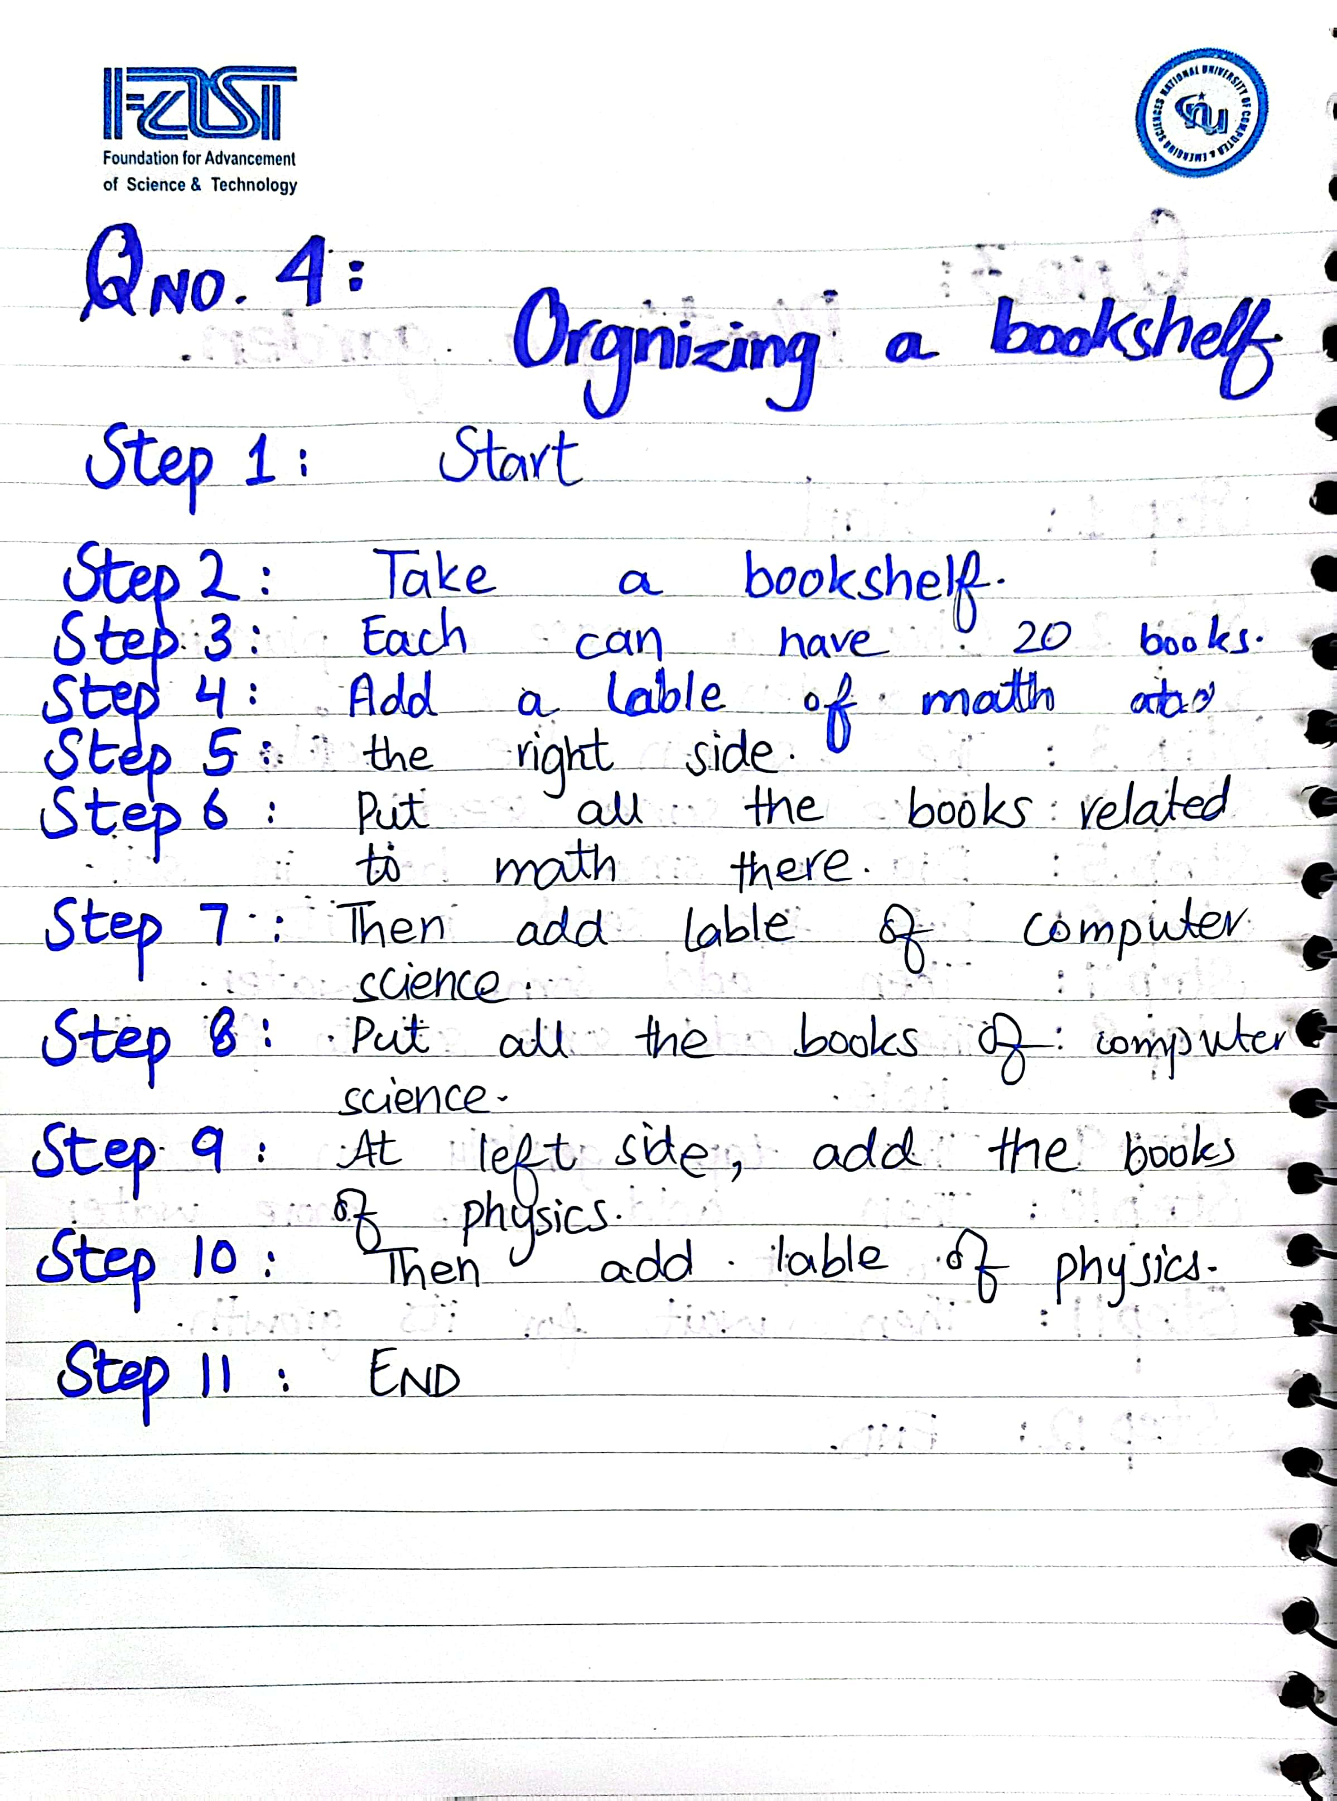

## Problem # 5

## Solution:

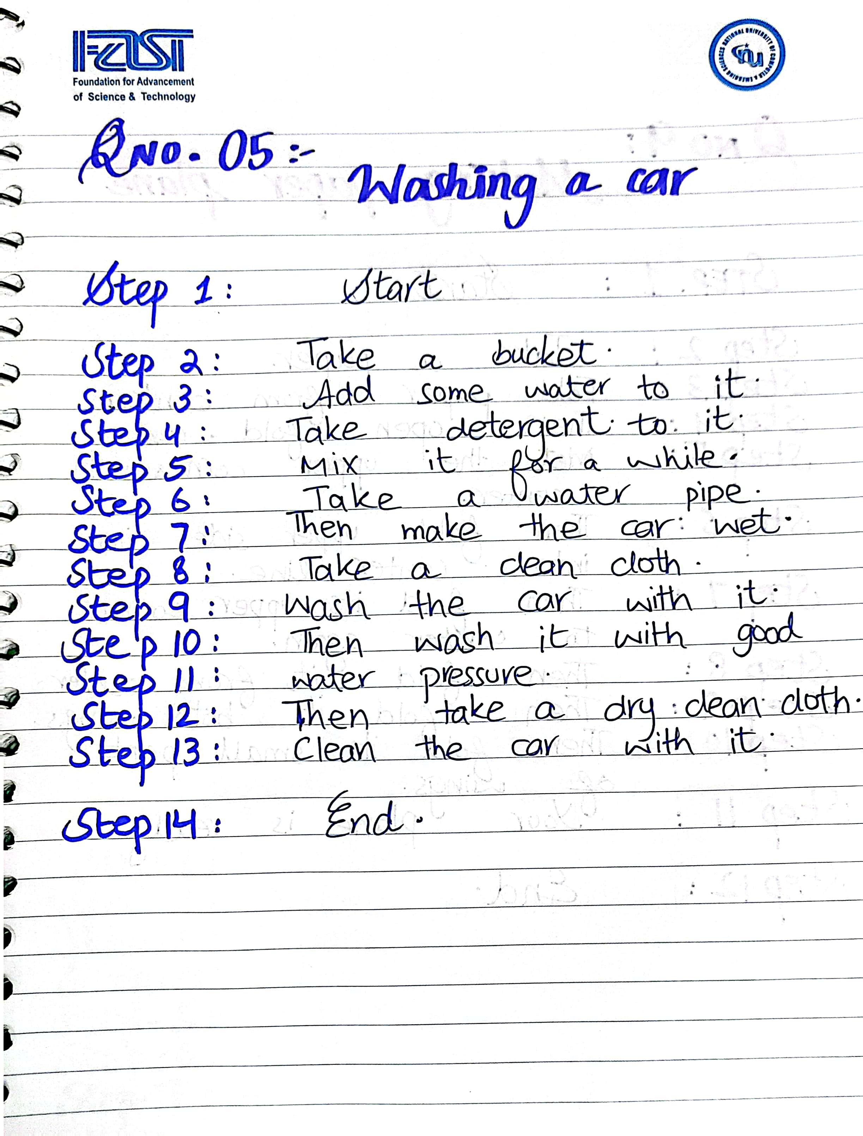

## Problem # 6

## Solution:

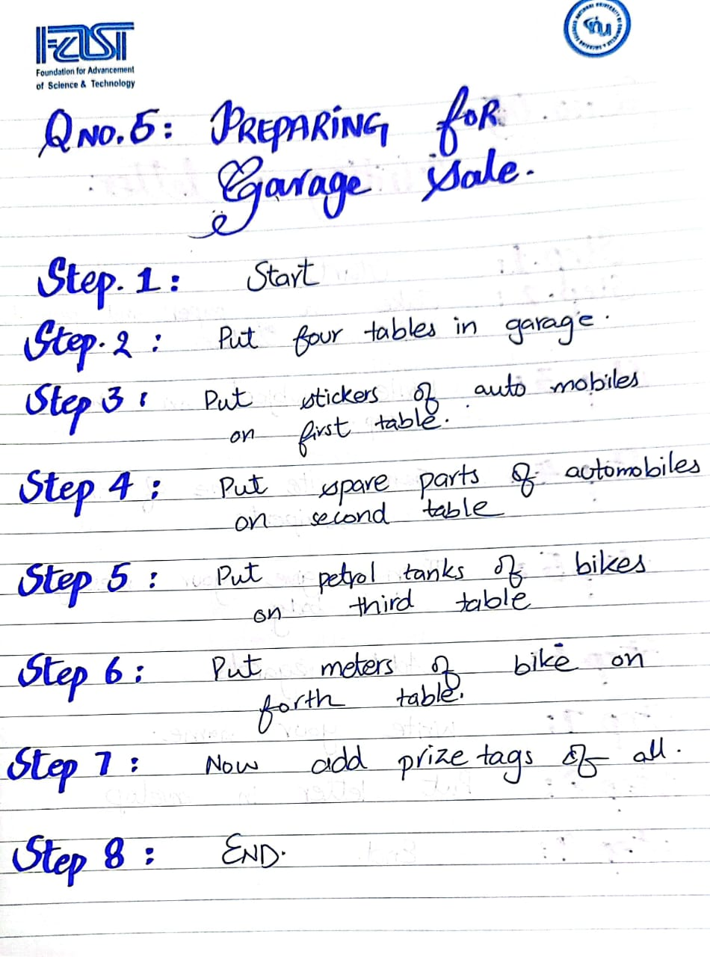

## Problem # 7

Solution:

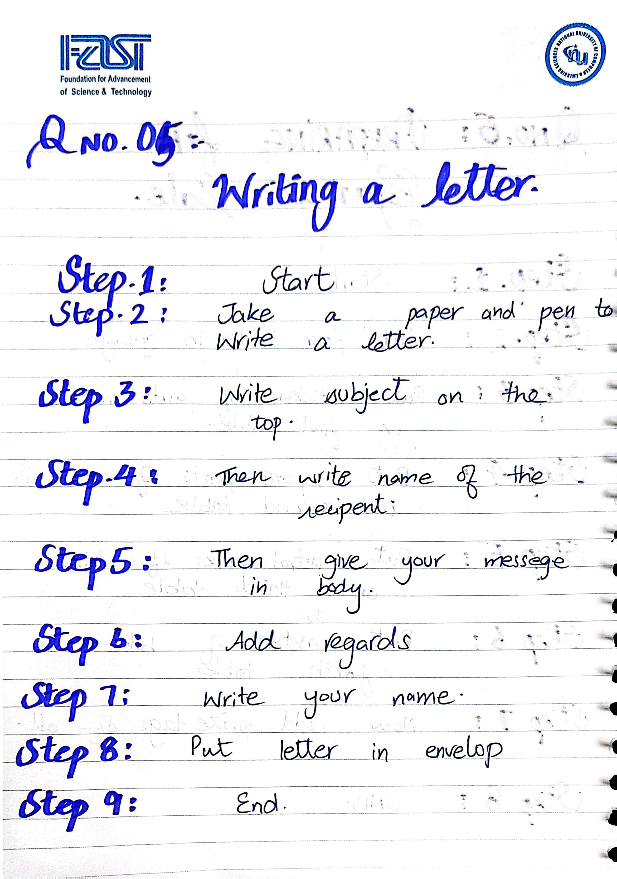

## Problem # 8

Solution:

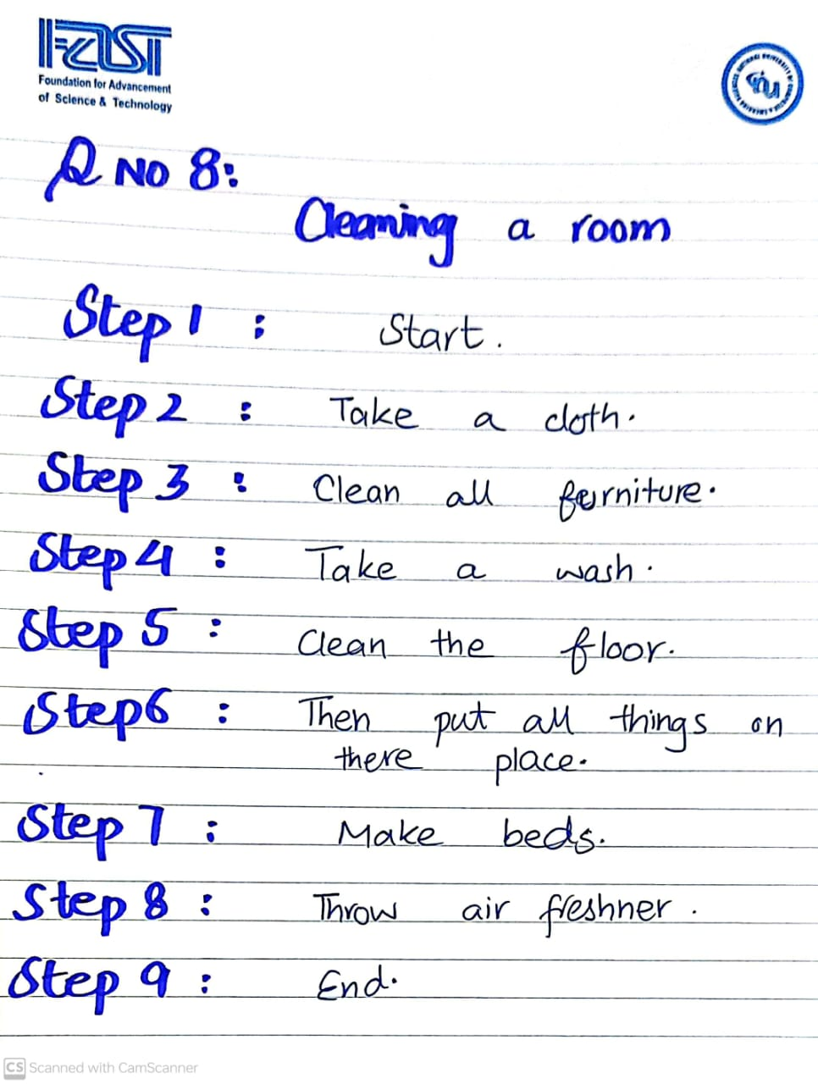

## Problem # 9

Solution:

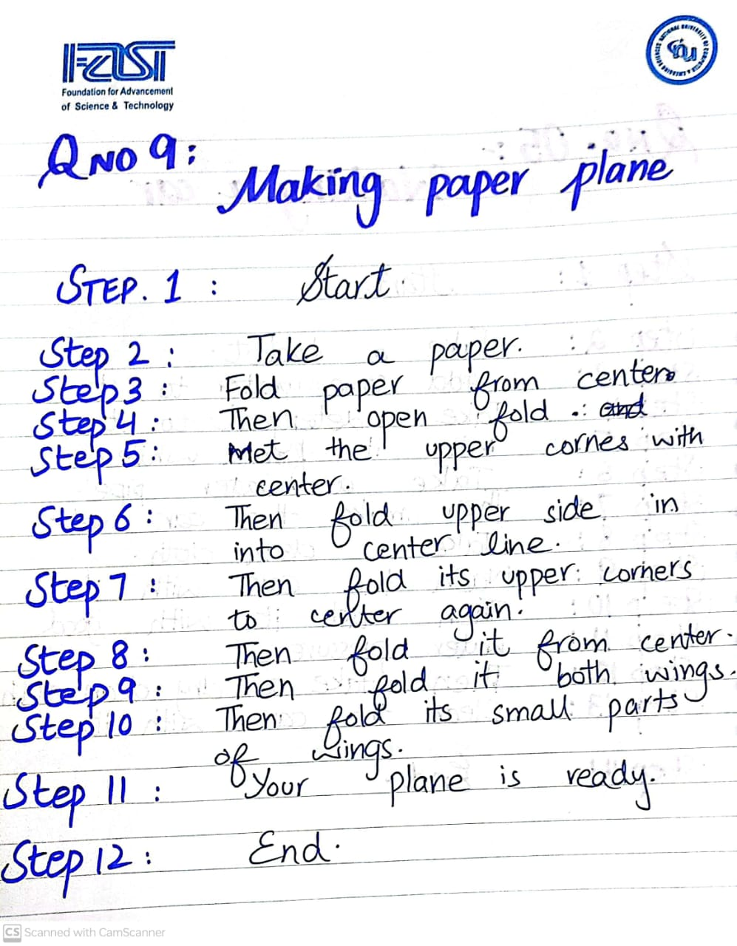

## Problem # 10

Solution:

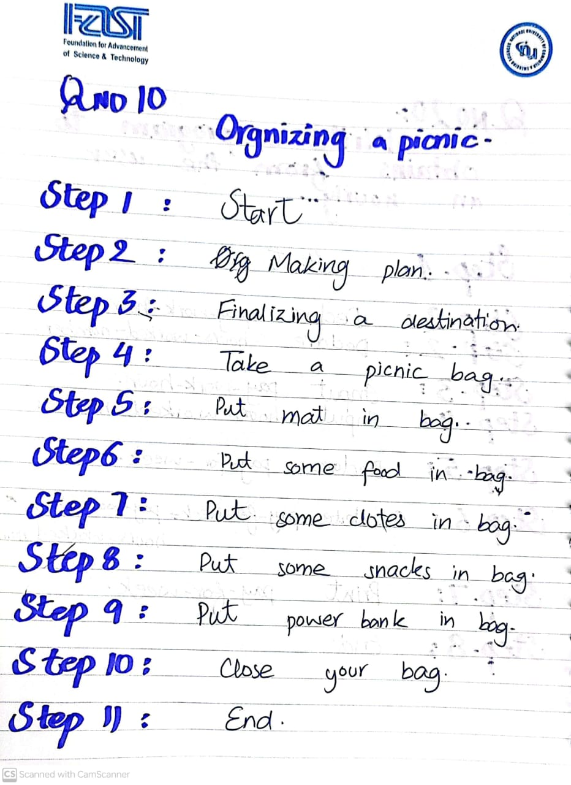

## Problem # 11

Solution:

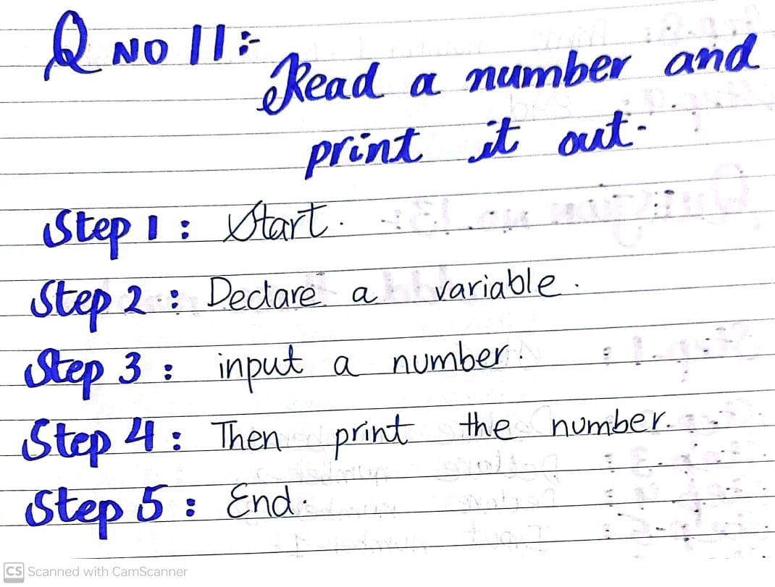

## Problem # 12

Solution:

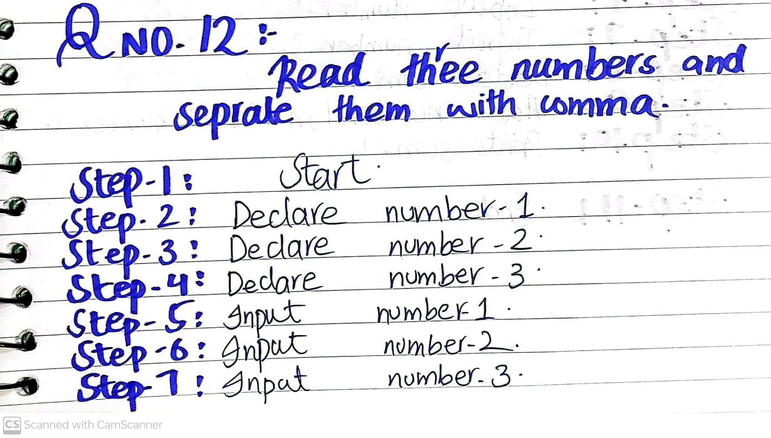

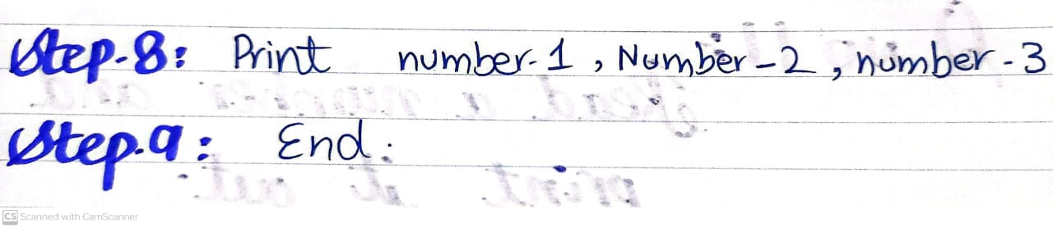

## Problem # 13

Solution:

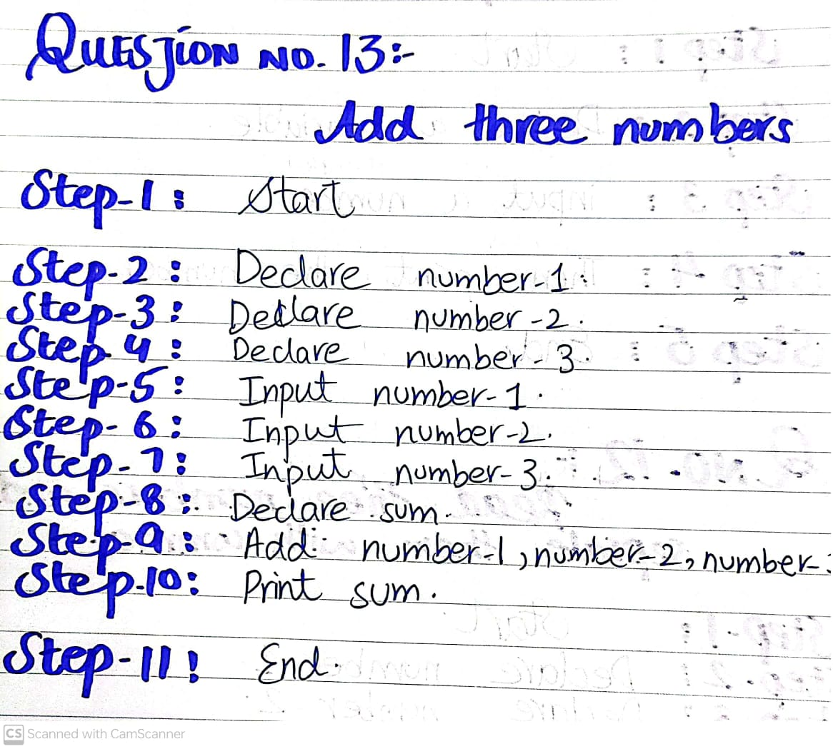

## Problem # 14

Solution:

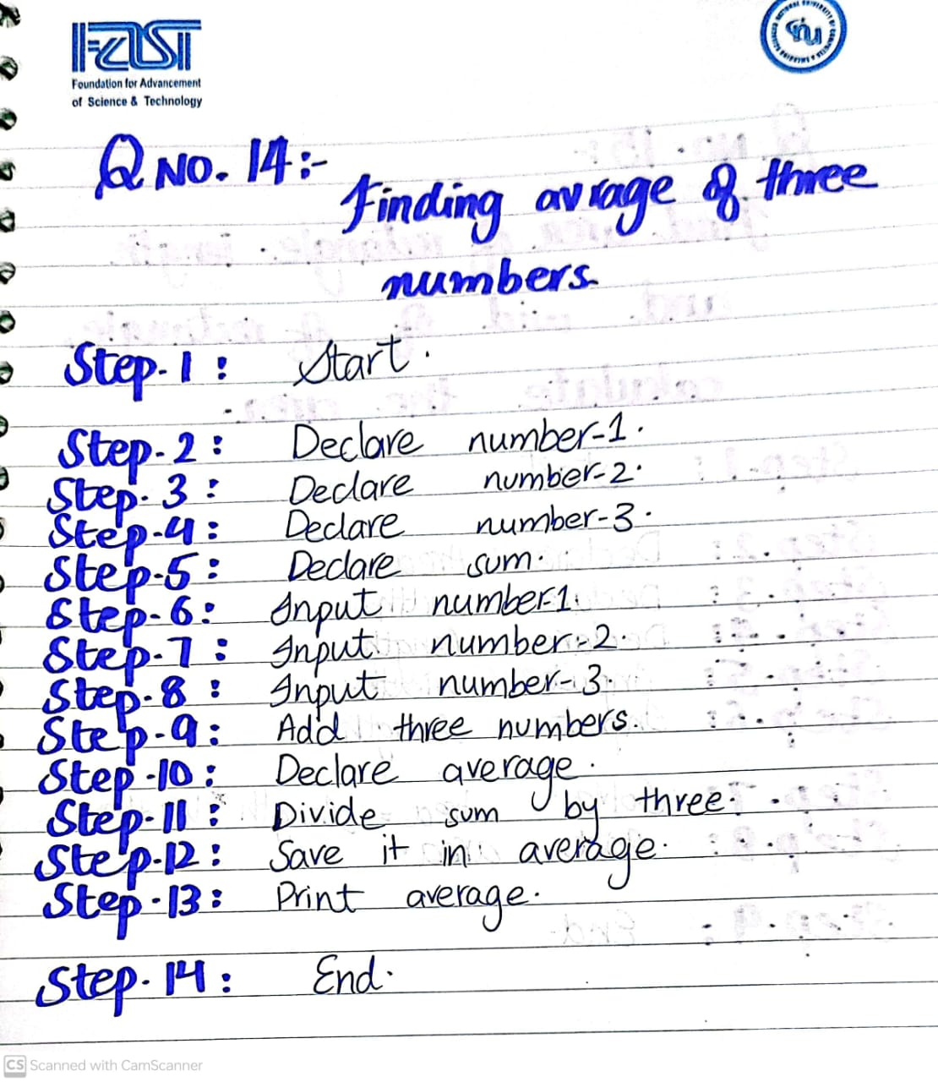

## Problem # 15

Solution:

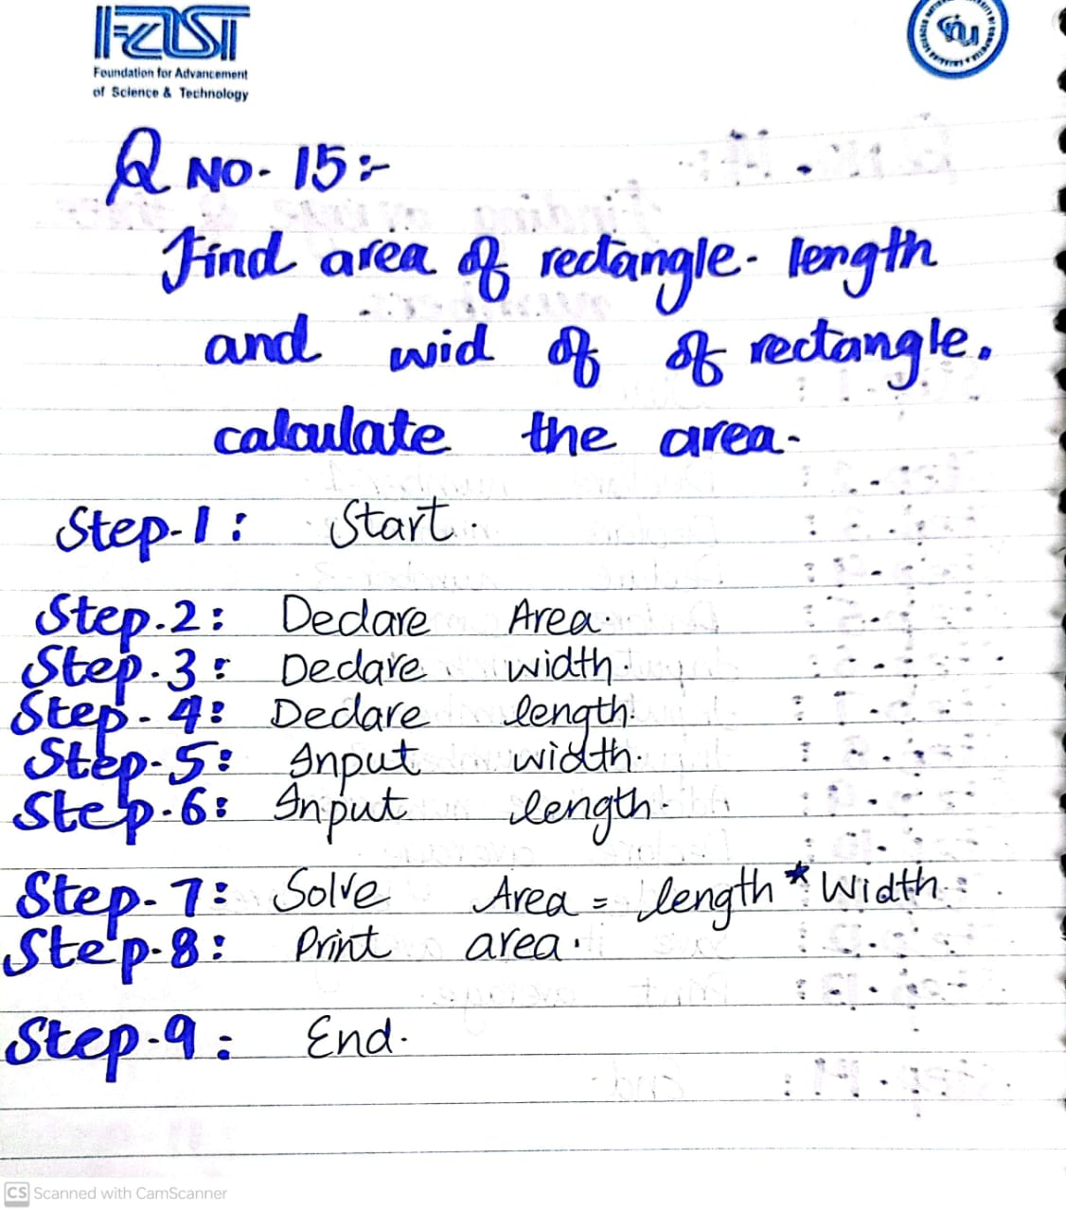

## Problem # 16

Solution:

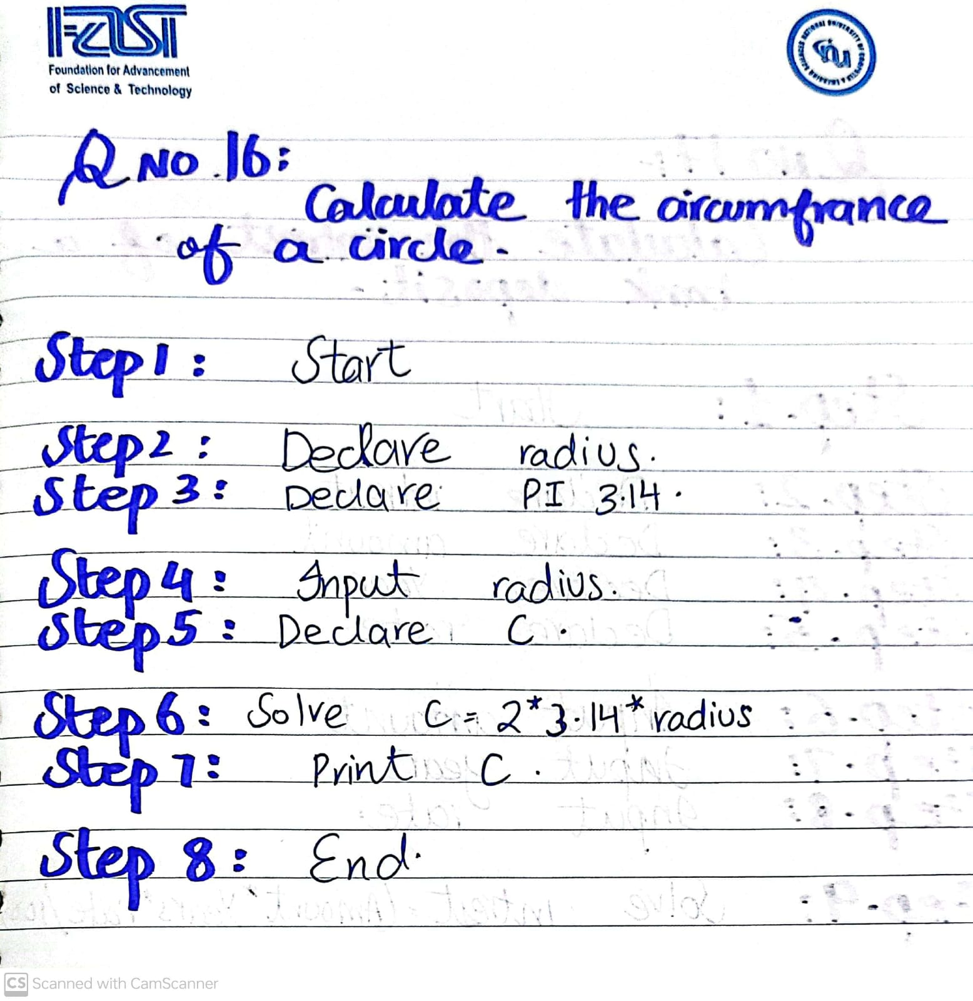

## Problem # 17

Solution:

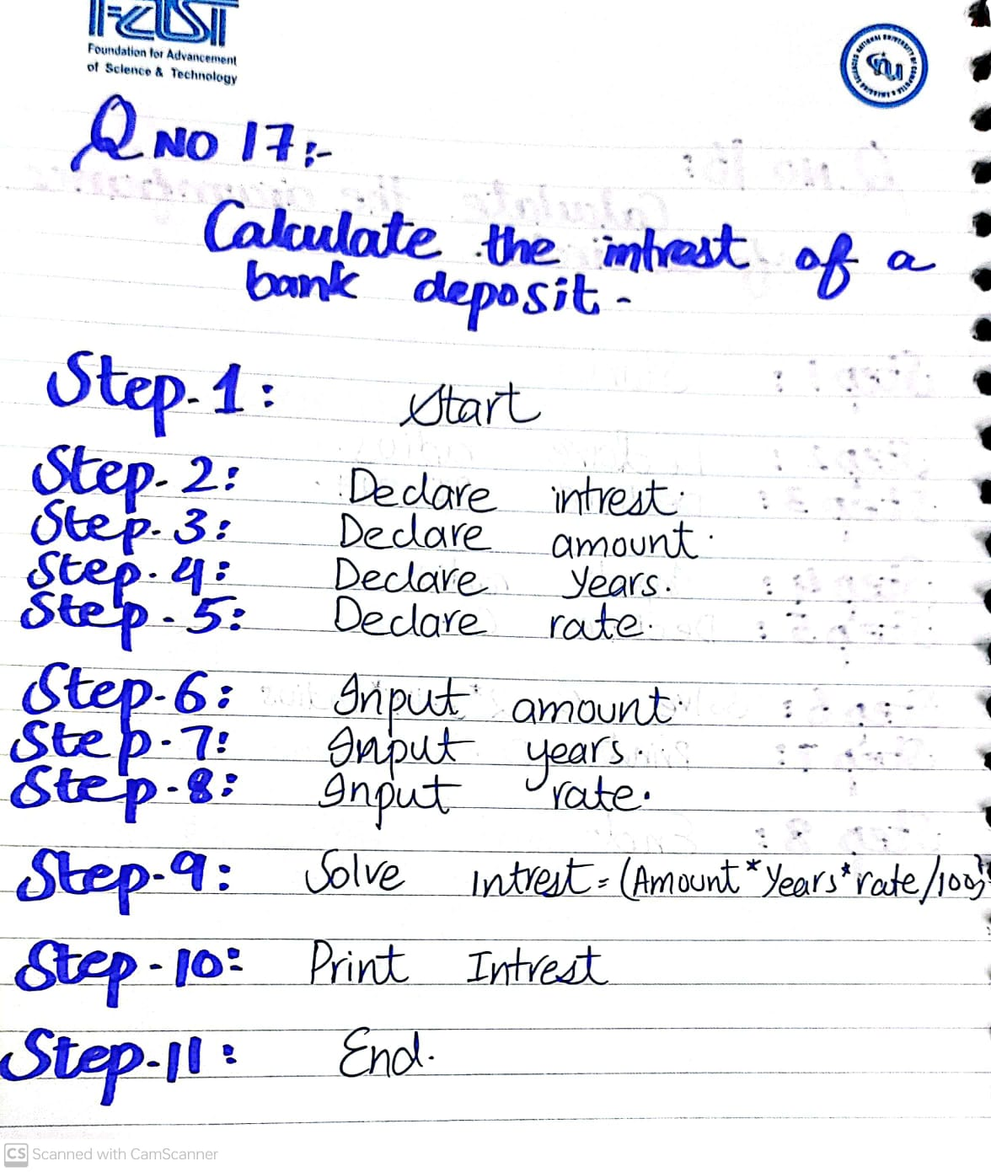

## Problem # 18

Solution:

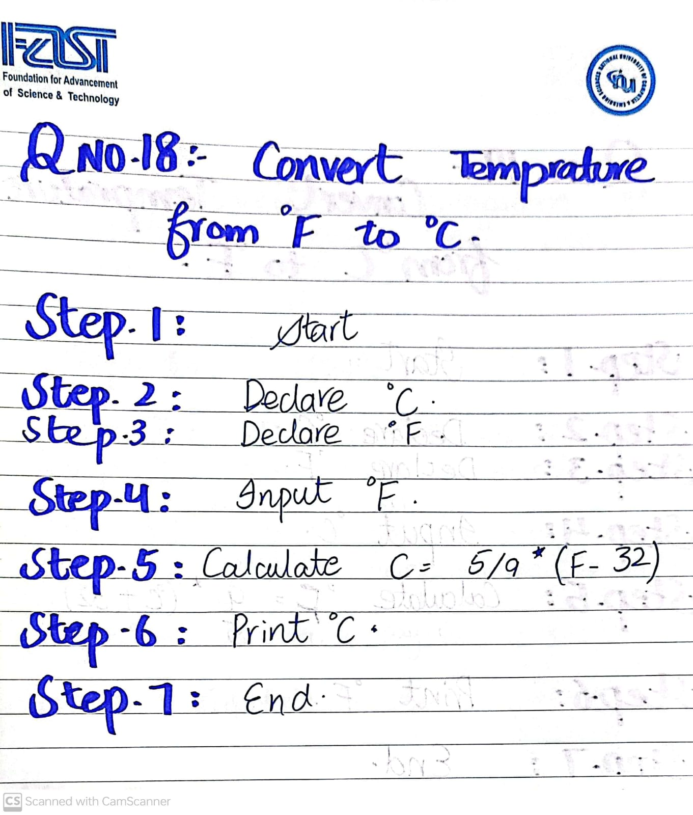

## Problem # 19

Solution:

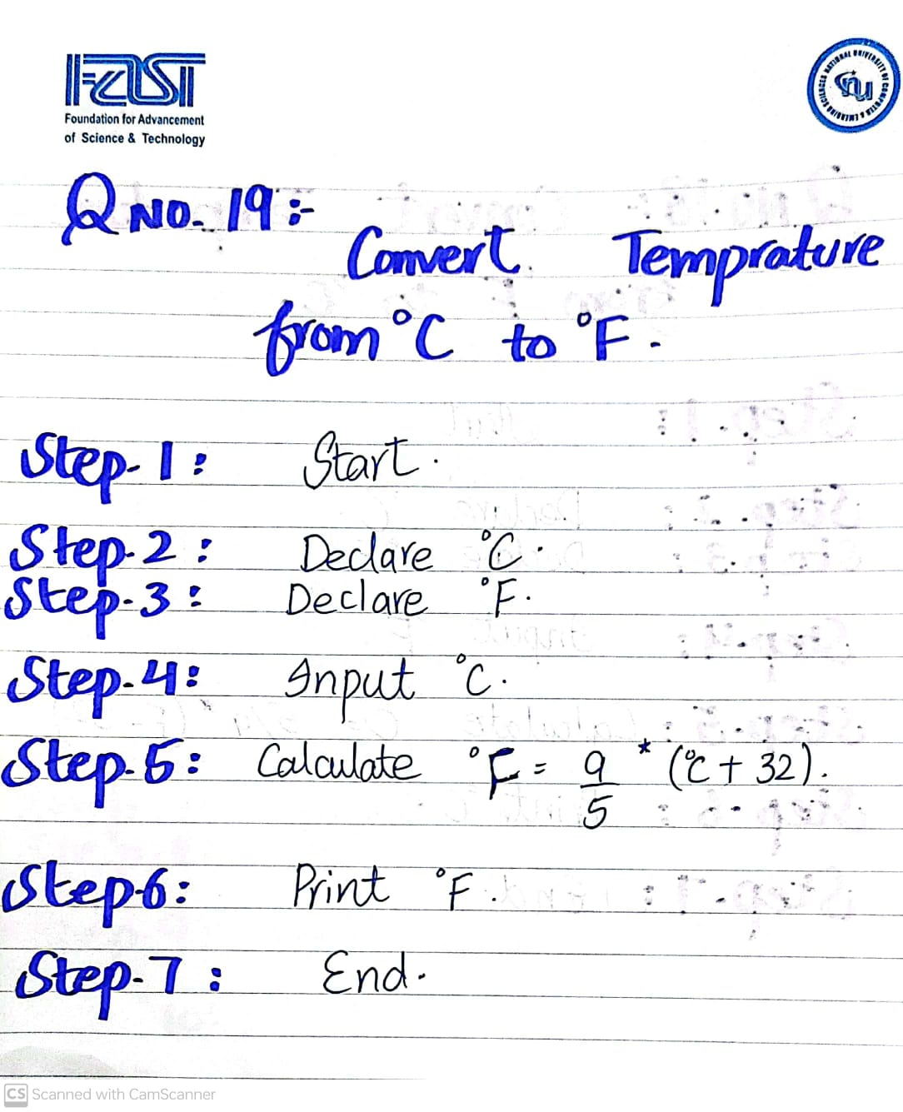

## Problem # 20

Solution:

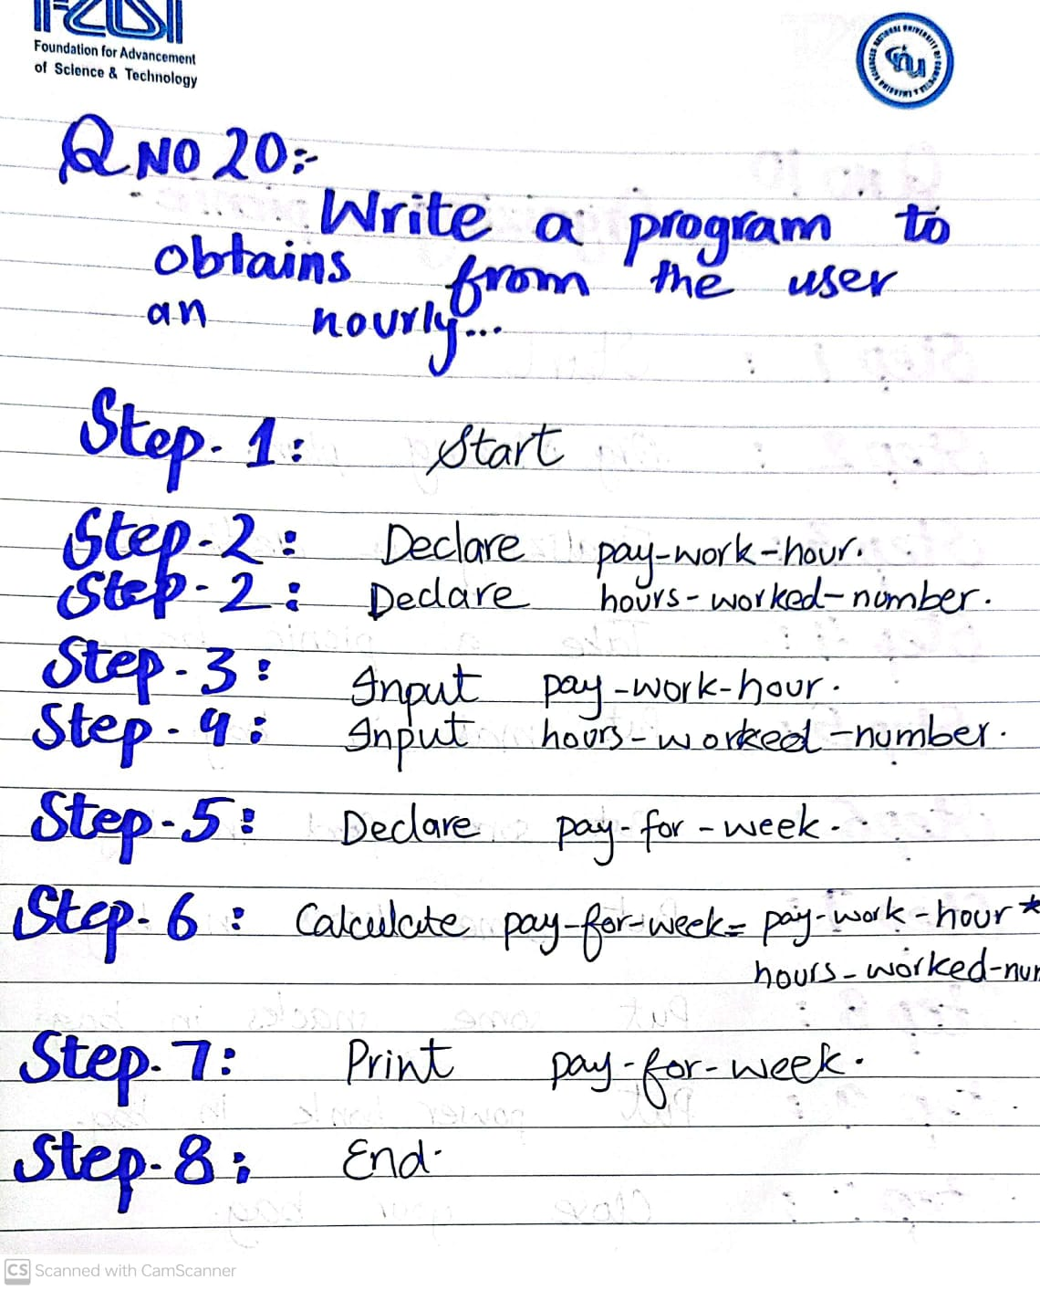

**THE END**